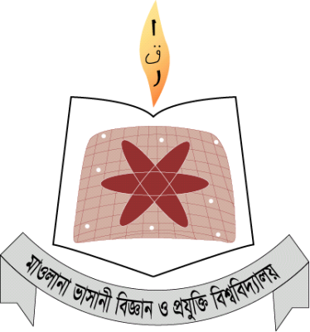

|  |  |
| --- | --- |
| Course Code – ICT4102 | Software Engineering Lab |

DEPARTMENT OF INFORMATION AND COMMUNICATION TECHNOLOGY

**Group Members:**

1) **MD. TAJUL ISLAM** (IT-13052)

2) **SARWAR JAHAN** (IT-13040)